**Table A. Relative risks per one IQR increase of air pollutants on cardiovascular disease and respiratory ER visits for the concurrent day.**

|  |  |  |  |  |  |  |  |
| --- | --- | --- | --- | --- | --- | --- | --- |
| Air pollution | IQR  (𝜇g/m3) | Cardiovascular diseases | | | Respiratory diseases | | |
|  |  | RR | 95% CI | P-value | RR | 95% CI | P-value |
| PM10 | 27.05 | 1.01\* | (1.00,1.02) | 0.004 | 0.99 | (0.98,1.01) | 0.573 |
| PM2.5 | 13.90 | 1.01\* | (1.00,1.02) | 0.002 | 1.00 | (0.98,1.01) | 0.711 |
| OC | 3.90 | 1.02 | (1.00,1.05) | 0.069 | 0.98 | (0.94,1.03) | 0.491 |
| EC | 0.89 | 1.01 | (0.99,1.04) | 0.036 | 1.00 | (0.95,1.05) | 0.975 |
| SO42 | 3.85 | 1.02 | (1.00,1.04) | 0.057 | 1.03 | (0.99,1.07) | 0.133 |
| NO3- | 5.58 | 1.02 | (1.00,1.04) | 0.144 | 1.01 | (0.98,1.05) | 0.503 |
| NH4+ | 5.09 | 1.05\* | (1.01,1.09) | 0.023 | 1.01 | (0.94,1.09) | 0.693 |

CI, confidence interval; IQR, interquartile range; RR, relative risk

\* p-value of RRs < 0.05

**Table B. Relative risks (RRs) per one IQR increase of each PM2.5 components on cardiovascular disease and respiratory ER visits in multi pollutant models.**

|  |  |  |  |  |
| --- | --- | --- | --- | --- |
| Variables | Air pollution | RR | 95% CI | P-value |
| Cardiovascular diseases | **OC** | 1.01 | (0.93 , 1.09) | 0.84 |
|  | **EC** | 1.02 | (0.95 , 1.10) | 0.56 |
|  | **SO42-** | 1.03 | (0.98 , 1.07) | 0.28 |
|  | **NO3-** | 0.99 | (0.95 , 1.04) | 0.80 |
|  | **NH4+** | 1.00 | (0.94 , 1.07) | 0.93 |
| Respiratory diseases | **OC** | 0.98 | (0.86 , 1.12) | 0.79 |
|  | **EC** | 1.09 | (0.97 , 1.23) | 0.16 |
|  | **SO42-** | 0.99 | (0.92 , 1.07) | 0.82 |
|  | **NO3-** | 1.00 | (0.93 , 1.07) | 1.00 |
|  | **NH4+** | 0.92 | (0.82 , 1.03) | 0.17 |

**Table C. Relative risks per one IQR increase of OC and ECon cardiovascular ER visits by age and gender**.

|  |  |  |  |  |  |  |  |
| --- | --- | --- | --- | --- | --- | --- | --- |
| Air pollution | Variables | Cardiovascular diseases | | | Respiratory diseases | | |
|  |  | RR | 95% CI | P-value | RR | 95% CI | P-value |
| OC | Age < 65 years old | 1.01 | (0.98,1.05) | 0.50 | 0.99 | (0.94,1.03) | 0.49 |
|  | Age ≥ 65 years old | 1.04\*\* | (1.00,1.08) | 0.08 | 0.98 | (0.93,1.04) | 0.54 |
|  | Male | 1.01 | (0.97,1.05) | 0.69 | 0.99 | (0.94,1.03) | 0.48 |
|  | Female | 1.04\* | (1.00,1.09) | 0.04 | 0.98 | (0.94,1.03) | 0.61 |
| EC | Age < 65 years old | 1.01 | (0.97,1.05) | 0.65 | 1.00 | (0.95,1.05) | 0.97 |
|  | Age ≥ 65 years old | 1.02 | (0.97,1.06) | 0.45 | 0.99 | (0.93,1.05) | 0.93 |
|  | Male | 1.00 | (0.96,1.04) | 0.95 | 1.01 | (0.96,1.06) | 0.63 |
|  | Female | 1.03 | (0.99,1.08) | 0.17 | 0.99 | (0.94,1.04) | 0.68 |

\* p-value of RRs < 0.05 \*\* p-value of RRs < 0.10

**Table D. Statistical tests for the comparison by age and gender.**

$$Z=\frac{β_{1}-β_{2}}{\sqrt{{({SE}_{β_{1}})}^{2}+{({SE}_{β_{2}})}^{2}}}$$

where $β_{1}$ is the coefficient about elderly patients or female, $β_{2}$ is the coefficient about younger patients or male, ${SE}_{β_{1}}$ is the standard error of $β_{1}$, and ${SE}_{β_{2}}$ is the standard error of $β_{2}$.

|  |  |  |  |  |  |
| --- | --- | --- | --- | --- | --- |
| Air pollution | Variables | Cardiovascular diseases | | | |
|  |  | Coefficient | SE | Z-statistics | P-value |
| OC | Age < 65 years old | 0.003 | 0.005 |  |  |
|  | Age ≥ 65 years old | 0.009 | 0.005 | 0.839 | 0.200 |
|  | Male | 0.002 | 0.005 |  |  |
|  | Female | 0.011 | 0.005 | 1.222 | 0.111 |
| EC | Age < 65 years old | 0.010 | 0.022 |  |  |
|  | Age ≥ 65 years old | 0.019 | 0.024 | 0.260 | 0.397 |
|  | Male | -0.001 | 0.024 |  |  |
|  | Female | 0.034 | 0.024 | 1.015 | 0.156 |

SE, standard error

**Table E. Relative risks per one IQR increase of SO42- on respiratory ER visits by age and gender for different lag days**.

|  |  |  |  |  |  |
| --- | --- | --- | --- | --- | --- |
| Air pollution | Variables | Lag 0 day | Lag 1 day | Lag 2 day | Lag 3 day |
| SO42- | All observations | 1.03  (0.99-1.07) | 1.04  (0.99-1.08) | 1.04  (1.00-1.08) | 1.04  (0.98-1.10) |
|  | Age < 65 years old | 1.03  (0.99-1.07) | 1.03  (0.99-1.08) | 1.04  (1.00--1.08) | 1.04  (0.98-1.11) |
|  | Age ≥ 65 years old | 1.02  (0.98-1.07) | 1.05  (1.00-1.10) | 1.00  (0.96-1.05) | 1.02  (0.96-1.08) |
|  | Male | 1.03  (0.99-1.07) | 1.03  (0.98-1.08) | 1.04  (1.00-1.08) | 1.03  (0.98-1.09) |
|  | Female | 1.03  (0.99-1.07) | 1.04  (1.00-1.09) | 1.04  (0.99-1.08) | 1.05  (0.99-1.11) |

**Table F. Sensitivity of the relative risks (RRs) per one IQR increase of PM2.5 and PM10 on cardiovascular disease and respiratory ER visits for the concurrent day by changing degree of freedom on temperature/time.**

|  |  |  |  |  |  |  |
| --- | --- | --- | --- | --- | --- | --- |
| Cardiovascular disease | | | | | | |
| Modeling Choices |  | df for time | RRs of PM10 | % Change | RRs of PM2.5 | % Change |
| Base model | With temperature | 6/year | 1.0141 | - | 1.0139 | - |
|  |  | 5/year | 1.0138 | -0.02 | 1.0138 | -0.01 |
|  |  | 7/year | 1.0142 | +0.01 | 1.0140 | +0.01 |
|  |  | 8/year | 1.0141 | +0.01 | 1.0142 | +0.02 |
| Base model | With time | 7/year | 1.0141 | - | 1.0139 | - |
|  |  | 6/year | 1.0146 | +0.05 | 1.0149 | +0.10 |
|  |  | 8/year | 1.0141 | +0.00 | 1.0157 | +0.18 |
|  |  | 10/year | 1.0135 | -0.05 | 1.0152 | +0.13 |

|  |  |  |  |  |  |  |
| --- | --- | --- | --- | --- | --- | --- |
| Respiratory disease | | | | | | |
| Modeling Choices |  | df for time | RRs of PM10 | % Change | RRs of PM2.5 | % Change |
| Base model | With temperature | 6/year | 0.9946 | - | 0.9967 | - |
|  |  | 5/year | 0.9935 | -0.11 | 0.9961 | -0.06 |
|  |  | 7/year | 0.9953 | +0.07 | 0.9971 | +0.04 |
|  |  | 8/year | 0.9952 | +0.06 | 0.9972 | +0.05 |
| Base model | With time | 7/year | 0.9946 | - | 0.9967 | - |
|  |  | 6/year | 0.9934 | -0.13 | 1.0028 | +0.62 |
|  |  | 8/year | 0.9903 | -0.44 | 0.9993 | +0.26 |
|  |  | 10/year | 0.9886 | -0.61 | 0.9923 | -0.44 |

C:\Users\황성희\Documents\School\plos one\20170329\S1_Fig.tiff**Fig A. Box plots of ER visits for cardiovascular diseases by age and gender.**

**C:\Users\황성희\Documents\School\plos one\20170329\S2_Fig.tiffFig B. Box plots of ER visits for respiratory diseases by age and gender.**

C:\Users\황성희\Documents\School\plos one\20170329\S3_Fig.tiff

**Fig C. Histograms of PM2.5 components’ concentrations**

**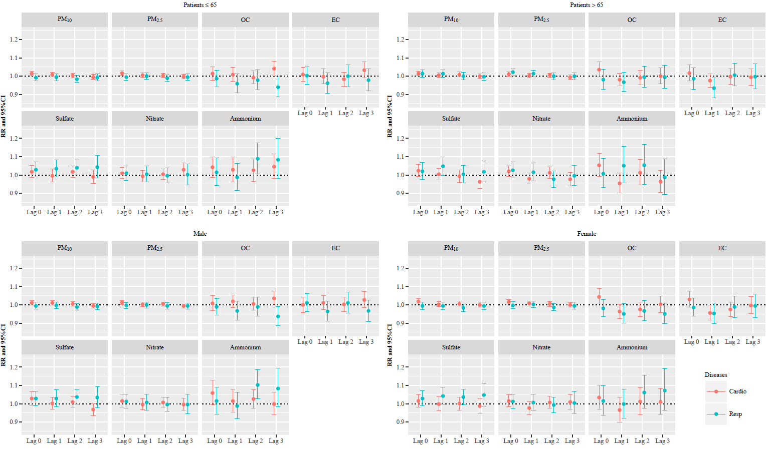**

**Fig D. RRs per one IQR increase of PM2.5 and its components on cardiovascular and respiratory ER visits for different lag days by age and gender.**